User manual
Sensitivity – concentration of organic compounds
The degree of colour change of the Carbotect product is directly related to the concentration of organic compounds in the water sample. Carbotect has been shown to be sensitive to the concentration of organic compounds as low as 0.05ppm (50ppb), and the intensity of the colour reaction can be directly correlated to the concentration of organic compounds when the colour change is evaluated after a fixed time period i.e. 5 minutes.
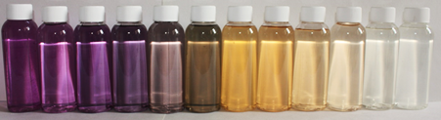
Glucose titration (L to R): Control, <1ppm through to 10,000ppm
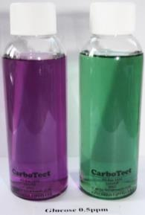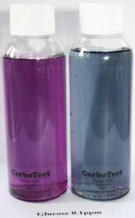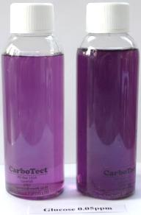
Glucose Monohydrate (L to R): Control (left), 0.5ppm, 0.1ppm, 0.05ppm - 5 minutes
Sensitivity – time based
30 minutes 90 minutes

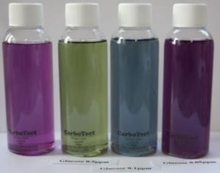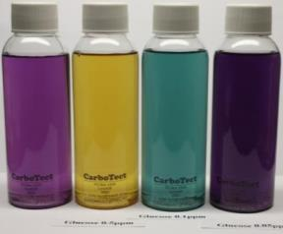
Glucose Monohydrate (left to right): Control, 0.5ppm, 0.1ppm, 0.05ppm

900 minutes (15 hours)
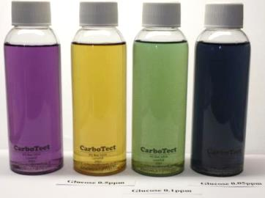
Glucose Monohydrate (left to right): Control, 0.5ppm, 0.1ppm, 0.05ppm

